

**CO2 WEB APPPREDICTION SYSTEM**

## By: Folasewa Abdulsalam, Adesanya Adenike, Ibrahim Murtala, Amaobichukwu Chibuzor

**ABSTRACT**.

They say too much of a good thing is a bad thing, this applies to atmospheric CO2: In higher concentrations, it is a damaging pollutant. Hence, industries that contribute to higher CO2 emission due to their production activities need to be able to use supervised machine learning techniques to predict CO2 emission and unsupervised machine learning techniques to discover new materials with low CO2 emission rate in their production processes. The case study for this project is the cement production industry. Carbon dioxide is an important component of the atmosphere because it plays multiple roles in keeping Earth’s climate stable. CO2 and other greenhouse gases are an essential part of the recipe because they trap heat in the atmosphere. With no CO2, Planet Earth would be in a perpetual ice age; However too much of it overheats the planet.

The deployed model is deployed as a web application that is capable of predicting CO2 emission from the masses of cement materials. A dataset containing cement materials is established for training and validating the model. The proposed model achieved an accuracy of 97%. Below is the snapshot of the dataset used in the model building.

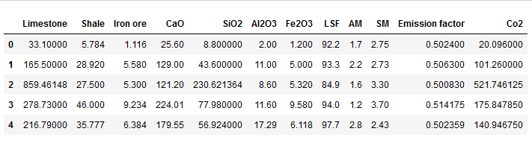

**INTRODUCTION**

Cement manufacturing industries contribute to greenhouse gases both directly through the production of carbon dioxide. In the process of making clinker which is the key constituent of cement that emits the largest amount of CO2 in cement making.

Being a significant CO2 emitter, measures have to be considered to reduce the CO2 emissions. There have been existing technologies for CO2 reduction, and this prompted for the development of a prediction system that predicts CO2 emission from clinker production materials. The solution proposed is a deployed web app that gives room for the user to input the masses of cement materials. The regression algorithm used is the linear regression.

In 2017, cement production contributed 7% of global CO2 emission. The diagram below is a pie chart supporting the claim.

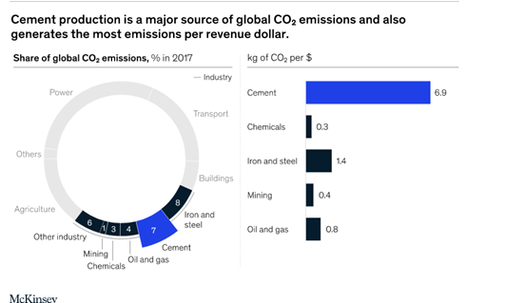

# DATA DESCRIPTION

# The data used is a synthesized data based on the knowledge acquired about the processes involving the production of cement. According to information from research articles, the raw mix design ratio of the main cement materials (limestone, shale, iron ore) which were given as 82.75, 14.46, and 2.79% respectively were varied during the preparation of the data, the percentage composition of CaO, SiO2, Al2O3, Fe2O3 were gotten when cement was exposed to X-ray were given as 60-65, 17-25, 3-7, 1.5-2.6% respectively were also varied, Lime Saturation Factor (LSF), Alumina Modulus (AM),Silica Modulus (SM) are calculated ratios used to guide the quality of clinker produced and their ideal values are given within the range of 93-97,1.4-1.9, and 2.5 using the designated formulas, emission factor was fraction of lime multiplied by a constant value (0.785) and finally CO2 emission was gotten by multiplying the emission factor by the clinker produced. For more information, visit the link below:

https://drive.google.com/drive/folders/1kXepopG_25MWb3vlGwpoDCriiFg_XthA?usp=sharing

# METHODOLOGY

The method we are adopting to predict emission of CO2 is supervised learning using Linear Regression.

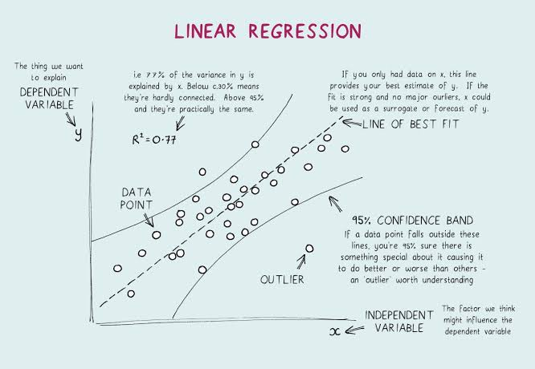

To completely model this problem, a dataset containing 12 columns and 70 rows of data which was formulated by the problem stakeholders using engineering principles guiding the production of cement and data gotten from experiments. See figure below for the correlation among features.

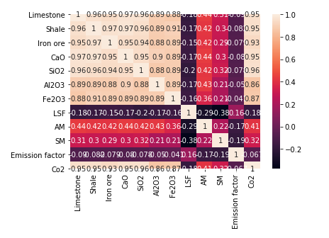

# DATA PREPROCESSING



* Missing data were filled with the mean of the data.
* Features with least correlation were dropped.
* Standard scaler was used in scaling down the features.

# MODEL ARCHITECTURE

The architecture used in modelling this problem is a Linear Regression model. Grid Search Cross validation of k-folds=5 was used with an hyperparameter range between 2 and 8 and estimator = rfe. The estimator Recursive Feature Elimination (rfe) was used because it would select features based on how well the affect the model’s performance. The diagram below shows the model architecture

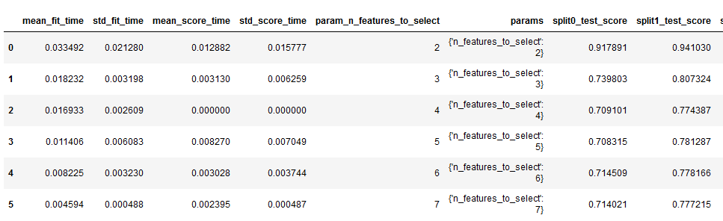

Plotting the CV results:

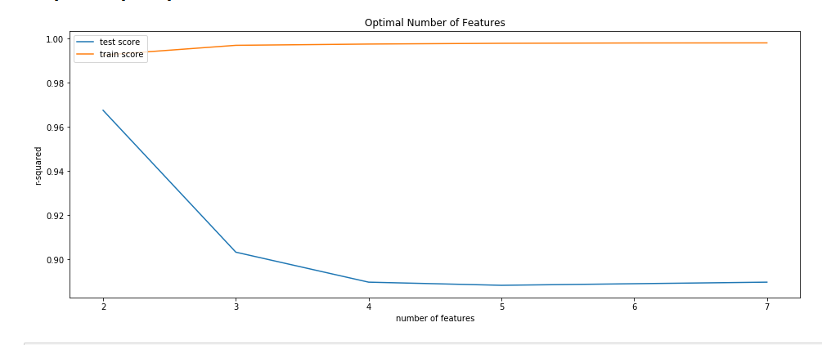

# 

# MODEL DEVELOPMENT

Streamlit was used in the model deployment and the figure below is a screenshot of the web app.

Link: <https://drive.google.com/file/d/1k1lP7a-dl76tpCq0UxzyUddfd3zxcZOU/view?usp=sharing>

# 

# RESULT

The following are the obtained results of the modelling. The metric used in evaluating this architecture is ‘accuracy’.

# REFERENCES



## <https://article.sapub.org/10.5923.j.control.20201001.03.html>

1. <https://www.understanding-cement.com/bogue.html>
2. <https://www.hindawi.com/journals/mpe/2012/392197/>
3. <https://www.researchgate.net/publication/269127824_A_Knowledge-Based_System_for_Mix_Design_of_Concrete_Containing_Pozzolanic_Materials>
4. <https://www.hindawi.com/journals/ace/2021/6682283/>